Project Title:
Design and Implementation of Snapchat Database using SQL
Submitted By:
Aishwarya Kamane
BBA (CA) – Final Year

Introduction:
The Snapchat Database System is designed to store and manage information related to users, profiles, friendships, messages, and stories. It maintains records of users who communicate on the platform by sending messages, adding friends, and sharing stories.
The main objective of this project is to understand how SQL tables, relationships, and queries work in a relational database system. It also demonstrates the practical use of SQL concepts for managing and retrieving social media data efficiently.

Database Setup and User Management:
To ensure secure database operations, a dedicated database user with appropriate privileges was created.
Step 1: Connect as SYSDBA
CONN / AS SYSDBA;
Step 2: Create Database User
CREATE USER snapchat_user IDENTIFIED BY snap123;
Step 3: Grant Privileges
GRANT ALL PRIVILEGES TO snapchat_user;
Step 4: Connect as Project User
CONN snapchat_user/snap123;
This process establishes a secure environment for creating tables, managing data, and executing SQL operations.

Database Schema Diagram:
The database employs a user-centric snowflake schema, optimized for clarity, scalability, and relational integrity.

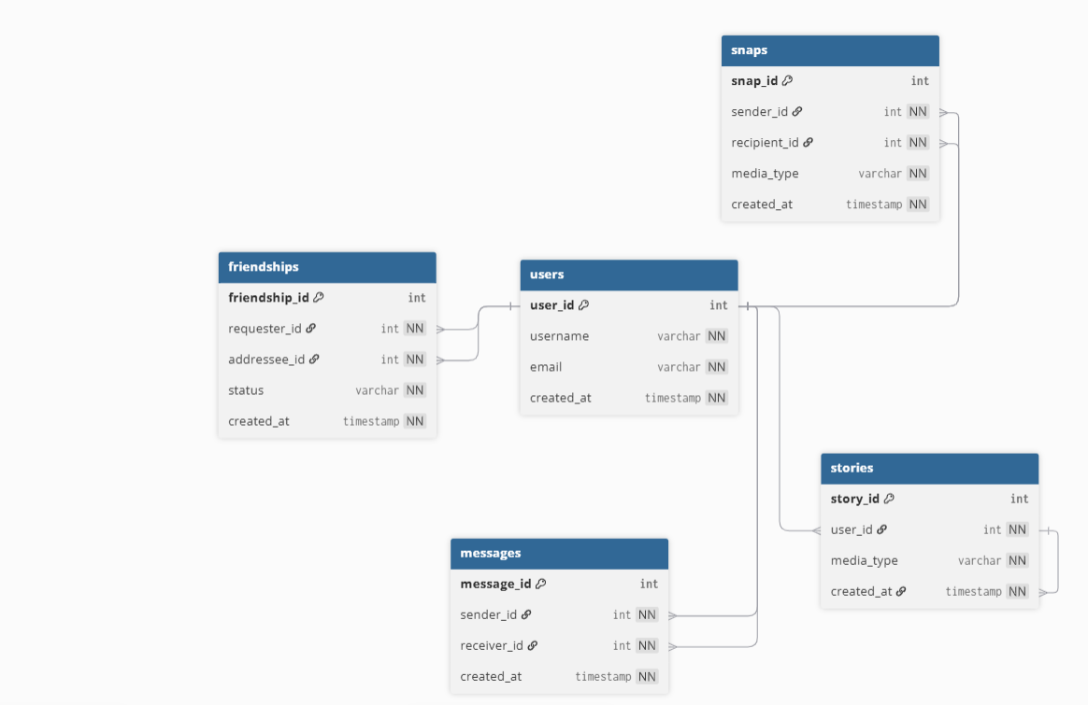
Core Entities:
Table Name | Purpose
USERS | Stores user account and profile information
FRIENDSHIPS | Manages friend requests, statuses, and connections
SNAPS | Records snaps sent between users
STORIES | Stores user-generated stories
MESSAGES | Captures messages exchanged between users

Relationship Types:
One-to-Many: A user can send multiple snaps, stories, and messages.
Many-to-One: Multiple snaps/messages can be received by a single user.
Self-Referencing: FRIENDSHIPS table links users to manage friend requests.
This design supports efficient query execution and accurately models real-world interactions on Snapchat.

Table Definitions and Attributes:
USERS Table
Column | Data Type | Description
USER_ID | NUMBER(10) | Primary key, unique identifier for each user
USERNAME | VARCHAR2(50) | User display name
EMAIL | VARCHAR2(100) | Registered email address
CREATED_AT | DATE | Account creation timestamp

FRIENDSHIPS Table
Column | Data Type | Description
FRIENDSHIP_ID | NUMBER(10) | Primary key, unique friendship ID
REQUESTER_ID | NUMBER | User initiating the request
ADDRESSEE_ID | NUMBER | User receiving the request
STATUS | VARCHAR2(20) | Request status (accepted/pending/declined)
CREATED_AT | DATE | Timestamp of request creation

SNAPS Table
Column | Data Type | Description
SNAP_ID | NUMBER(10) | Primary key, unique snap ID
SENDER_ID | NUMBER | User sending the snap
RECIPIENT_ID | NUMBER | User receiving the snap
MEDIA_TYPE | VARCHAR2(20) | Media type (photo/video)
CREATED_AT | DATE | Timestamp of snap creation

STORIES Table
Column | Data Type | Description
STORY_ID | NUMBER | Primary key, unique story ID
USER_ID | NUMBER | User posting the story
MEDIA_TYPE | VARCHAR2(20) | Story media type (photo/video)
CREATED_AT | DATE | Timestamp of story upload

MESSAGES Table
Column | Data Type | Description
MESSAGE_ID | NUMBER | Primary key, unique message ID
SENDER_ID | NUMBER | User sending the message
RECEIVER_ID | NUMBER | User receiving the message
CREATED_AT | DATE | Timestamp of message creation

Sample Data Overview:
Table | Records | Description
USERS | 10 | User account details
FRIENDSHIPS | 12 | Friend requests and connection statuses
SNAPS | 15 | Snaps exchanged between users
STORIES | 8 | User-generated stories
MESSAGES | 18 | Messages exchanged between users
Sample data validates database functionality and demonstrates relationships and query performance.

Some SQL Operations:
Retrieve usernames and emails:
SELECT USERNAME, EMAIL
FROM USERS;
Filter users created after a specific date:
SELECT *
FROM USERS
WHERE CREATED_AT > '03-JAN-26';
Count snaps sent by each user:
SELECT SENDER_ID, COUNT(*)
FROM SNAPS
GROUP BY SENDER_ID;
Count snaps sent by users with multiple snaps:
SELECT SENDER_ID, COUNT(*)
FROM SNAPS
GROUP BY SENDER_ID HAVING COUNT(*) > 1;

SQL> -- Snapchat Database SQL Queries
SQL> -- Project: Design and Implementation of Snapchat Database
SQL> -- Student Name: Aishwarya Kamane

SELECT * FROM TAB;

TNAME TABTYPE CLUSTERID
FRIENDSHIPS TABLE
MESSAGES TABLE
SNAPS TABLE
STORIES TABLE
USERS TABLE

SQL> SELECT * FROM USERS;
USER_ID USERNAME EMAIL CREATED_AT
1 rahul rahul@gmail.com 01-JAN-26
2 sneha sneha@gmail.com 02-JAN-26
3 rohan rohan@gmail.com 03-JAN-26
4 priya priya@gmail.com 04-JAN-26
5 amit amit@gmail.com 05-JAN-26
6 pooja pooja@gmail.com 06-JAN-26
7 nikhil nikhil@gmail.com 07-JAN-26
8 swapnil swapnil@gmail.com 08-JAN-26
9 anjali anjali@gmail.com 09-JAN-26
10 omkar omkar@gmail.com 10-JAN-26

10 rows selected.

SQL> SELECT * FROM FRIENDSHIPS;

FRIENDSHIP_ID REQUESTER_ID ADDRESSEE_ID STATUS CREATED_AT
------------- ------------ ------------ -------------------- ------------
1 1 2 accepted 11-JAN-26
2 1 3 accepted 12-JAN-26
3 2 4 pending 13-JAN-26
4 3 5 accepted 14-JAN-26
5 4 6 accepted 15-JAN-26
6 5 7 pending 16-JAN-26
7 6 8 accepted 17-JAN-26
8 7 9 accepted 18-JAN-26
9 8 10 pending 19-JAN-26
10 2 5 accepted 20-JAN-26
11 3 7 accepted 21-JAN-26
12 4 9 pending 22-JAN-26

12 rows selected.

SQL> SELECT * FROM SNAPS;

SNAP_ID SENDER_ID RECIPIENT_ID MEDIA_TYPE CREATED_AT
---------- ---------- ------------ -------------------- ------------
1 1 2 image 23-JAN-26
2 2 1 video 24-JAN-26
3 3 5 image 25-JAN-26
4 4 6 image 26-JAN-26
5 5 7 video 27-JAN-26
6 6 8 image 28-JAN-26
7 7 9 image 29-JAN-26
8 8 10 video 30-JAN-26
9 9 1 image 31-JAN-26
10 10 2 video 01-FEB-26
11 1 3 image 02-FEB-26
12 2 4 video 03-FEB-26
13 3 6 image 04-FEB-26
14 4 8 video 05-FEB-26
15 5 9 image 06-FEB-26

15 rows selected.

SQL> SELECT * FROM STORIES;

STORY_ID USER_ID MEDIA_TYPE CREATED_AT
---------- ------- -------------------- ------------
1 1 image 07-FEB-26
2 2 video 08-FEB-26
3 3 image 09-FEB-26
4 4 video 10-FEB-26
5 6 image 11-FEB-26
6 7 video 12-FEB-26
7 9 image 13-FEB-26
8 10 video 14-FEB-26

8 rows selected.

SQL> SELECT * FROM MESSAGES;

MESSAGE_ID SENDER_ID RECEIVER_ID CREATED_AT
---------- ---------- ----------- ------------
1 1 2 15-FEB-26
2 2 1 15-FEB-26
3 3 5 16-FEB-26
4 5 3 16-FEB-26
5 4 6 17-FEB-26
6 6 4 17-FEB-26
7 7 9 18-FEB-26
8 9 7 18-FEB-26
9 8 10 19-FEB-26
10 10 8 19-FEB-26
11 1 3 20-FEB-26
12 3 1 20-FEB-26
13 2 4 21-FEB-26
14 4 2 21-FEB-26
15 5 7 22-FEB-26
16 7 5 22-FEB-26
17 6 8 23-FEB-26
18 8 6 23-FEB-26

18 rows selected.

SQL> -- Starting SQL queries USING WHERE, GROUP BY, HAVING, INNER JOIN, SUBQUERY and SINGLE ROW FUNCTIONS.

SQL> --DISPLAY ALL USERS WHOSE USERNAME IS RAHUL.
SQL> SELECT *
2 FROM USERS
3 WHERE USERNAME='rahul';

USER_ID USERNAME EMAIL CREATED_AT
------- ------------ ------------------------- ------------
1 rahul rahul@gmail.com 01-JAN-26

SQL> --DISPLAY ALL SNAPS WHERE MEDIA TYPE IS VIDEO.
SQL> SELECT *
2 FROM SNAPS
3 WHERE MEDIA_TYPE='video';

SNAP_ID SENDER_ID RECIPIENT_ID MEDIA_TYPE CREATED_AT
---------- ---------- ------------ -------------------- ------------
2 2 1 video 24-JAN-26
5 5 7 video 27-JAN-26
8 8 10 video 30-JAN-26
10 10 2 video 01-FEB-26
12 2 4 video 03-FEB-26
14 4 8 video 05-FEB-26

6 rows selected.

SQL> --COUNT THE NUMBER OF SNAPS SENT BY EACH USER.
SQL> SELECT SENDER_ID, COUNT(*) AS TOTAL_SNAPS
2 FROM SNAPS
3 GROUP BY SENDER_ID;

SENDER_ID TOTAL_SNAPS
---------- -----------
1 2
6 1
2 2
4 2
5 2
8 1
3 2
7 1
9 1
10 1

10 rows selected.

SQL> --COUNT THE NUMBER OF MESSAGES SENT BY EACH USER.
SQL> SELECT SENDER_ID, COUNT(*) AS TOTAL_MESSAGES
2 FROM MESSAGES
3 GROUP BY SENDER_ID;

SENDER_ID TOTAL_MESSAGES
---------- --------------
1 2
6 2
2 2
5 2
4 2
8 2
3 2
7 2
9 1
10 1

10 rows selected.

SQL> --DISPLAY USERS WHO HAVE SENT MORE THAN 1 SNAP
SQL> SELECT SENDER_ID, COUNT(*)
2 FROM SNAPS
3 GROUP BY SENDER_ID
4 HAVING COUNT(*)>1;

SENDER_ID COUNT(*)
---------- ----------
1 2
2 2
4 2
5 2
3 2

SQL> --DISPLAY USERS WHO HAVE SENT MORE THAN 1 MESSAGE.
SQL> SELECT SENDER_ID, COUNT(*)
2 FROM MESSAGES
3 GROUP BY SENDER_ID
4 HAVING COUNT(*)>1;

SENDER_ID COUNT(*)
---------- ----------
1 2
6 2
2 2
5 2
4 2
8 2
3 2
7 2

8 rows selected.

SQL> --FIND USERS WHO SENT MORE THAN ONE IMAGE SNAP.
SQL> SELECT SENDER_ID, COUNT(*)
2 FROM SNAPS
3 WHERE MEDIA_TYPE='image'
4 GROUP BY SENDER_ID
5 HAVING COUNT(*)>1;

SENDER_ID COUNT(*)
---------- ----------
1 2
3 2

SQL> --FIND REQUESTERS WHO HAVE MORE THAN ONE ACCEPTED FRIENDSHIP.
SQL> SELECT REQUESTER_ID, COUNT(*)
2 FROM FRIENDSHIPS
3 WHERE STATUS='accepted'
4 GROUP BY REQUESTER_ID
5 HAVING COUNT(*)>1;

REQUESTER_ID COUNT(*)
------------ ----------
1 2
3 2

SQL> --FIND USERS WHO SENT MORE THAN ONE MESSAGE AFTER 16-FEB-26.
SQL> SELECT SENDER_ID, COUNT(*)
2 FROM MESSAGES
3 WHERE CREATED_AT > TO_DATE('16-FEB-2026','DD-MON-YYYY')
4 GROUP BY SENDER_ID
5 HAVING COUNT(*)>1;

SENDER_ID COUNT(*)
---------- ----------
6 2
4 2
8 2
7 2

SQL> --DISPLAY USERNAME AND STORY MEDIA TYPE.
SQL> SELECT U.USERNAME, S.MEDIA_TYPE
2 FROM USERS U
3 INNER JOIN STORIES S
4 ON U.USER_ID=S.USER_ID;

USERNAME MEDIA_TYPE
------------ --------------------
rahul image
sneha video
rohan image
priya video
pooja image
nikhil video
anjali image
omkar video

8 rows selected.

SQL> --DISPLAY USERNAME AND SNAP MEDIA TYPE.
SQL> SELECT U.USERNAME, S.MEDIA_TYPE
2 FROM USERS U
3 INNER JOIN SNAPS S
4 ON U.USER_ID=S.SENDER_ID;

USERNAME MEDIA_TYPE
------------ --------------------
rahul image
sneha video
rohan image
priya image
amit video
pooja image
nikhil image
swapnil video
anjali image
omkar video
rahul image
sneha video
rohan image
priya video
amit image

15 rows selected.

SQL> --DISPLAY USERNAME WHO SENT IMAGE SNAPS.
SQL> SELECT U.USERNAME, S.MEDIA_TYPE
2 FROM USERS U
3 INNER JOIN SNAPS S
4 ON U.USER_ID=S.SENDER_ID
5 WHERE S.MEDIA_TYPE='image';

USERNAME MEDIA_TYPE
------------ --------------------
rahul image
rohan image
priya image
pooja image
nikhil image
anjali image
rahul image
rohan image
amit image

9 rows selected.

SQL> --DISPLAY USERNAMES WHO POSTED VIDEO STORIES
SQL> SELECT U.USERNAME, S.MEDIA_TYPE
2 FROM USERS U
3 INNER JOIN STORIES S
4 ON U.USER_ID=S.USER_ID
5 WHERE S.MEDIA_TYPE='video';

USERNAME MEDIA_TYPE
------------ --------------------
sneha video
priya video
nikhil video
omkar video

SQL> --DISPLAY USERNAMES OF USERS WHO SENT SNAPS;
SQL> SELECT USERNAME
2 FROM USERS
3 WHERE USER_ID IN
4 (SELECT SENDER_ID FROM SNAPS);

USERNAME
------------
rahul
sneha
rohan
priya
amit
pooja
nikhil
swapnil
anjali
omkar

10 rows selected.

SQL> --DISPLAY USERNAMES OF USERS WHO POSTED STORIES.
SQL> SELECT USERNAME
2 FROM USERS
3 WHERE USER_ID IN
4 (SELECT USER_ID FROM STORIES);

USERNAME
------------
rahul
sneha
rohan
priya
pooja
nikhil
anjali
omkar

8 rows selected.

SQL> --FIND USERNAMES WHO SENT MORE THAN 1 SNAP.
SQL> SELECT USERNAME
2 FROM USERS
3 WHERE USER_ID IN
4 (
5 SELECT SENDER_ID
6 FROM SNAPS
7 GROUP BY SENDER_ID
8 HAVING COUNT(*)>1
9 );

USERNAME
------------
rahul
priya
sneha
amit
rohan

SQL> --DISPLAY USERNAMES WHO SENT MESSAGES.
SQL> Display usernames who sent messages.
SP2-0734: unknown command beginning "Display us..." - rest of line ignored.
SQL> SELECT USERNAME
2 FROM USERS
3 WHERE USER_ID IN
4 (SELECT SENDER_ID FROM MESSAGES);

USERNAME
------------
rahul
sneha
rohan
amit
priya
pooja
nikhil
anjali
swapnil
omkar

10 rows selected.

SQL> --DISPLAY USERNAMES IN UPPERCASE.
SQL> SELECT UPPER(USERNAME)
2 FROM USERS;

UPPER(USERNAME)
--------------------------------------------------
AMIT
ANJALI
NIKHIL
OMKAR
POOJA
PRIYA
RAHUL
ROHAN
SNEHA
SWAPNIL

10 rows selected.

SQL> --DISPLAY USERNAMES AND THEIR LENGTH.
SQL> SELECT USERNAME, LENGTH(USERNAME)
2 FROM USERS;

USERNAME LENGTH(USERNAME)
------------ ----------------
amit 4
anjali 6
nikhil 6
omkar 5
pooja 5
priya 5
rahul 5
rohan 5
sneha 5
swapnil 7

10 rows selected.

SQL> --DISPLAY FIRST 3 CHARACTERS OF USERNAMES.
SQL> SELECT USERNAME, SUBSTR(USERNAME,1,3)
2 FROM USERS;

USERNAME SUBSTR(USERN
------------ ------------
amit ami
anjali anj
nikhil nik
omkar omk
pooja poo
priya pri
rahul rah
rohan roh
sneha sne
swapnil swa

10 rows selected.

